Saving a Document

With Google Docs

- Before any type of document is saved, it is important to name the document. Click on the Untitled title of the document. A Rename window will open.

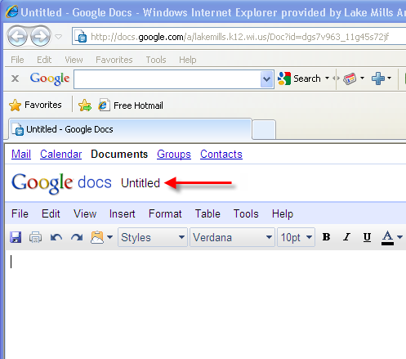

- Type in the new name of the document. Click OK.
Note: If the user does not choose to enter a title for a document, Google Docs will take the first few words typed into the document and it will use that as the document’s title.

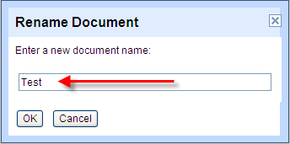
- To save the file, click on the File Tab. A drop down list will appear. Click Save to save the document and continue working. Click Save and close to save the document and close the document window.

